**Lesson3 APP10:**

**Initialize a Volume Restored from a Snapshot on Linux**

**Selecting the snapshot:**

* Go to EC2 dashboard in EBS and click on *Snapshot*

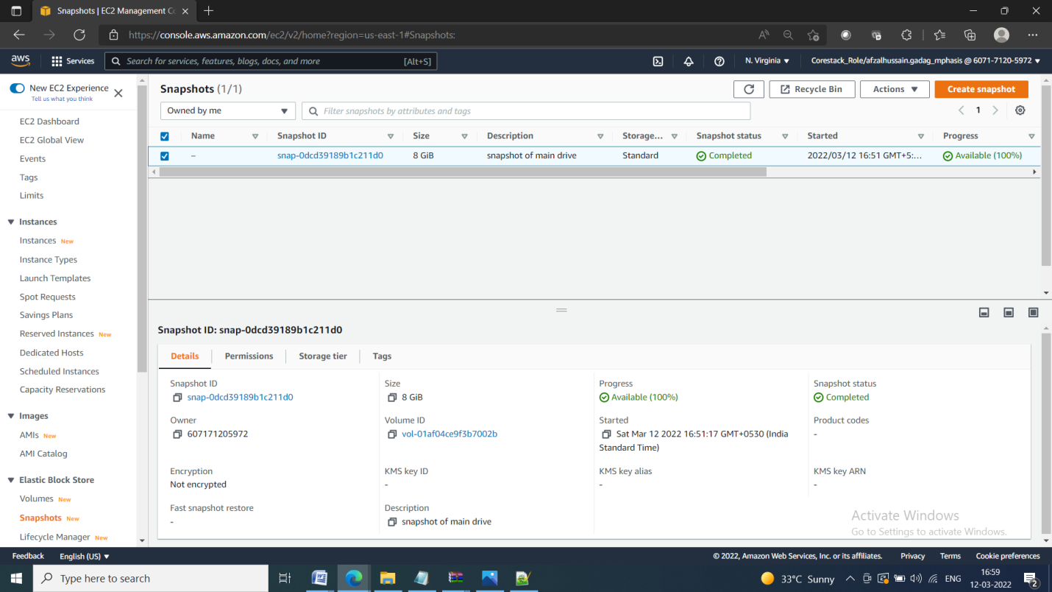

**Restoring volume from the snapshot:**

* Select the snapshot and click on *Action*

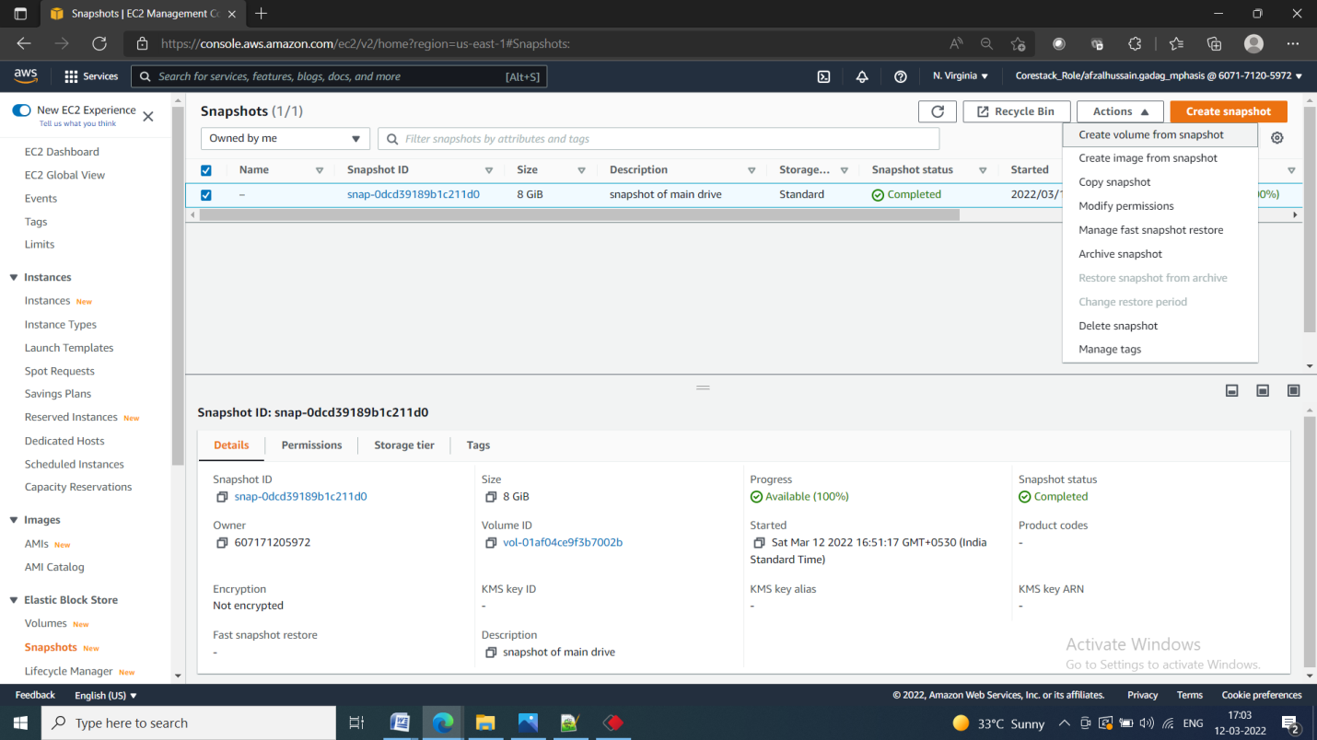

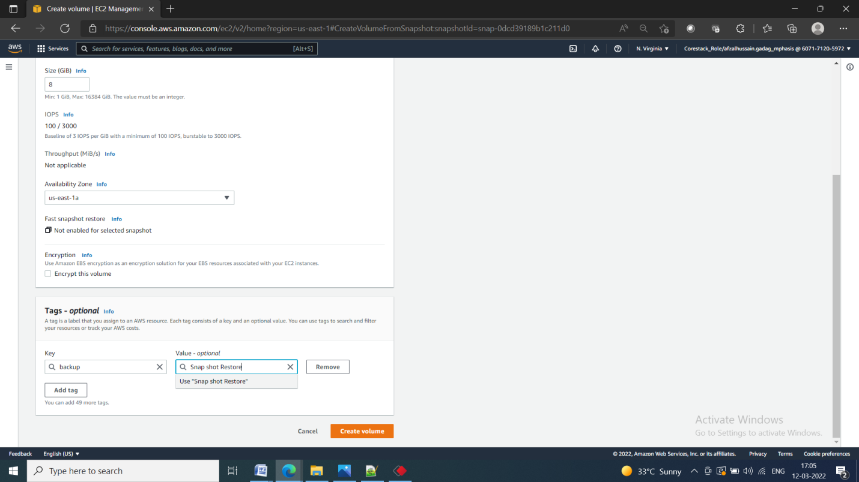

* Restore the volume from the snapshot

